Name: Vivek Vikram Pundkar

Roll no: 77

GR no: 11910860

Division: C

Batch: 3

**Quick Sort**

--------------------------------------------------------------------------------------------------------------

**Code**:

//Quick Sort algorithm

void quickSort(int array[], int low, int high)

{

if (low < high)

{

int pi = partition(array, low, high);

quickSort(array, low, pi - 1);

quickSort(array, pi + 1, high);

}

}

**Output:**

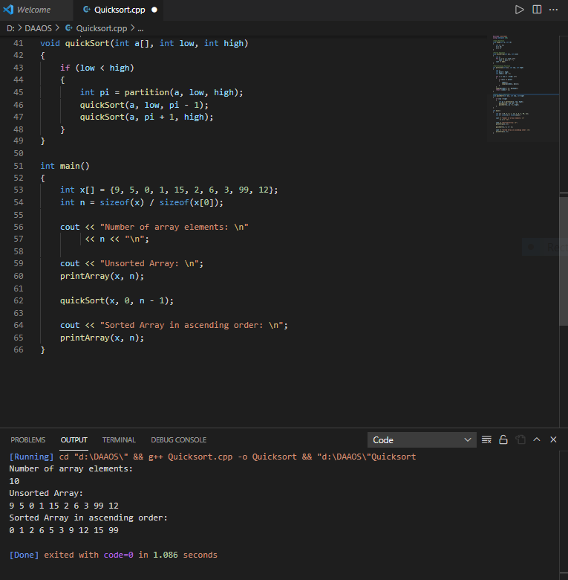

**Analysis:**

**Time Complexity of Quick Sort**

**Best case:**

The best-case time complexity of Quick Sort is **O(nlogn)**. When we consider pivot as mean element.

**Worst case:**

The worst-case time complexity of Quick Sort is **O(n2)**. When the array is sorted and we consider smallest or largest element as pivot.

**Average case:**

The average case complexity of the quick sort algorithm is **O(n logn)**.Here the number of chances to get a pivot element is equal to the number of items.

**Space Complexity of Quick sort**

We are only considering the given array, so the space complexity of Quick sort is **O(n)**